AP/ITEC3210 O - Applied Data Communications and Networks (Winter 2020-2021)

02/11/2021

ITEC Assignment 1

Part 1

Structured Design

A structured network design is a model that uses a top-down sequence to design each module of a network separately, satisfying the application requirements and logical structure before the implementation of the physical component (Oppenheimer, 2004).

Major Benefits

* The design approach ensures that the application requirements are provided
* Network segments are independently functional

How it Applies to S&G Network

All the departments of S&G will be fully functional network segments, and department critical activities can be achieved independently.

2

Micro Services Architecture

S&G is a multi-department organization, basing on the required network structure, having different specialized functions with the need for a level of autonomy. The Microservice architecture allows software components to function independently ("CLOUD-NATIVE APPLICATIONS"), hence its adoption. The enterprise application can function independently for each department.

3

1. Hardware Components needed.

* Router
* Layer 3 Switch
* Layer 2 Switch
* Servers

1. Specific Purposes

* Router - for the implementation of security policies, considering that S&G may require internet access.
* Layer 3 Switch - coordinating the different network segments on both layer two and layer three services.
* Layer 2 Switches - To coordinate the activities of end-users within each network segment.
* Servers - To host the enterprise applications for each network segment.

1. Required quantity

* Router - 1
* Layer 3 Switch - 1
* Layer 2 Switches - 4
* Servers - 16

4

1. 10Base-T is an ethernet cable standard transmitting 10 Mbps over twisted pair, 100Base-T transmits 100Mbps over twisted pair, 1000Base-T transmits 1000Mbps over twisted pair, 1000Base-F transmits 1Gbps over Fiber Optics, 10GbE transmits 10 Gbps under IEEE 802.3ae-2002 standard, 40GbE transmits 40 Gbps under IEEE 802.3ae-2002 standard, 100GbE transmits 100 Gbps under IEEE 802.3ae-2002 standard ("Definition Of 10Base-T").
2. Technical Goals

* Availability: - The transmission speed determines the availability of the services to the user from the server, as insufficient bandwidth can impact service availability.
* Quality of Service: - The transmission speed determines the access quality end users have to the applications on the server. Seamless access is an important indicator.
* Scalability: - The transmission speed can affect the number of users and services that can be added to a network.

5

1. The enterprise application that will be running on it, and the kind of services the SOS will be providing for the application, like database or web services.
2. User requirement: - If many users need to have access to one PC on different work schedules, there will be a need for Server OS utilities, peculiar to a particular SOS vendor.
3. Support Option: - Considering S&G networks will be using legacy applications or not, compatibility issues with new updates on applications can be supported by the SOS vendor.
4. Staff Support Skillset: - Considering the skillset of the organization’s IT staff, a Server Operating System that can be supported by the staff would be a better choice.

(Bekman)

6

1. The Unix SOS runs database processes while Oracle platforms run the database processes on windows. Unix may be more efficient in managing database services.
2. Windows SOS provides active directory services, but Unix OS will have to run on Samba or any other application that allows the windows active directory service to run on Linux
3. Windows have an efficient support mechanism for SOS and PC OS, while Linux is disadvantaged in this premise.
4. Windows has a less complicated support mechanism, and it is easy to learn and support. Most Unix server utilities are Command-line based, making windows more suitable for the organization's support staff.

("Linux Or Windows for Oracle?")

Windows SOS is recommended.

7

|  |  |  |  |
| --- | --- | --- | --- |
| Device | Specification | Quantity | Price |
| Router | Cisco 4451-X Integrated Services Router - Application Experience with Voice | 1 | $21,016.84 |
| Layer 3 Switch | Cisco Catalyst 9300 - Network Essentials - switch - 24 ports - managed – ra | 1 | $8,882.49 |
| Layer 2 Switch | Cisco Catalyst 2960L-48TS-LL - switch - 48 ports - managed - rack-mountable | 4 | $1,398.39  Total = $5,593.56 |
| Cables | Cat 6 | 5 | $200.00  Total = 1000.00 |
| Server | HPE ProLiant BL460c Gen10 - blade - Xeon Gold 5120 2.2 GHz - 64 GB - no HDD | 16 | Not Available |
| PC | Compare HP ProOne 600 G6 AIO 21.5" Core i5-10500 8GB RAM 256GB SSD W10P | 48 | $1,254.05  Total = $60,194.40 |
| Network Printers | HP LaserJet Enterprise MFP M578dn - multifunction printer – color | 8 | $1,799.00  Total = $14,392.00 |

Total = $111,079.29 + 8 Servers

8

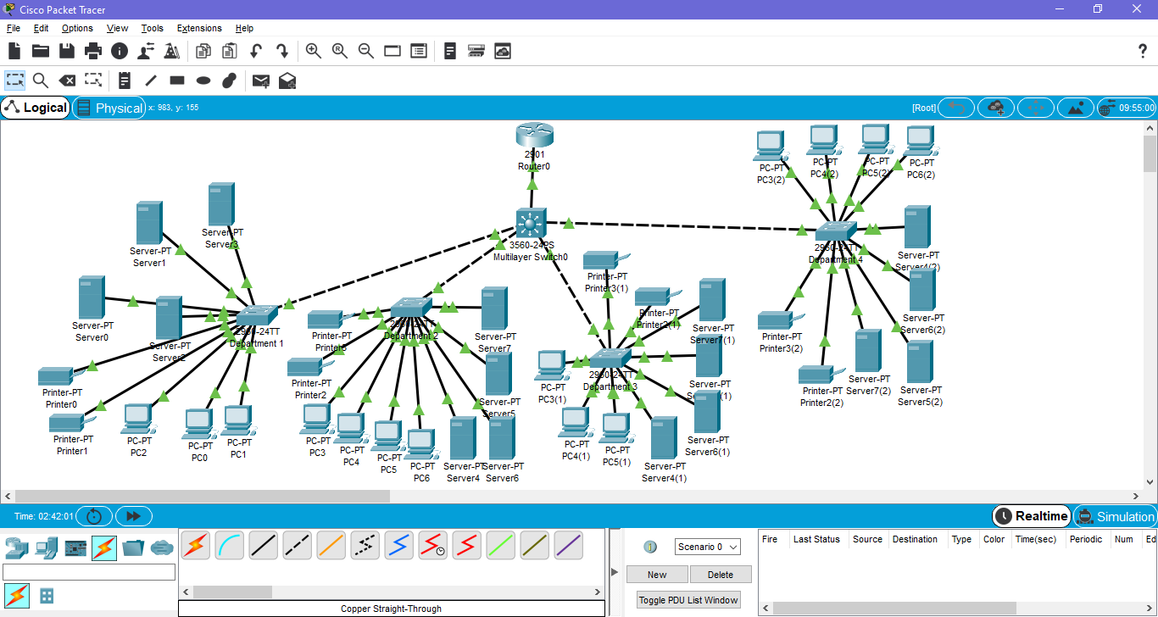

Part 2

* The number of bits that must be borrowed for the subnet ID would be log2(8). This equals to 3 which means that the number of bits that must be borrowed for the subnet ID is 3.
* The current mask would be 255.255.255.0.For the subnet mask, there are 24 bits for the network and 8 bits for the host since it is a class C network. We are borrowing 3 bits for subnets which makes it 27 bits for the network. This makes the subnet mask 255.255.255.224.

11111111.1111111.11111111.00000000 (this is 24 bit, we need to borrow 3 bits.)

11111111.1111111.11111111.11100000 (27 bit network)

* (2^5) = 32 - 2(subtract 2 because of the network and broadcaster) = 30. There can be 30 hosts on each subnet.
* 3 bits are being borrowed, 2^3 = 8, There are 8 possible subnets.
* Subnetting helps to save IP addresses because less hosts are wasted. If there are, for example, 25 hosts for a network then only 5 hosts are wasted in a 30 host subnet. If this was a class B address, then there would be thousands of wasted IP addresses.
* To allow for expansion with this subnetting solution, you would have to add an additional 2 subnets that are unused on the network totaling 10 subnets. This would double the amount of subnets you can have allowing for more ip addresses.

Part 3

* A managed network is one that consists of hardware and software that work together to record data and make reports if needed.                                                                                               FitzGerald, Jerry, et al. *Business Data Communications and Networking*. Wiley, 2017.

* The components of a managed network include device, system, and application management software that work with the hardware of the system. All of these are used together to monitor the system and uphold and maintain the network.               FitzGerald, Jerry, et al. *Business Data Communications and Networking*. Wiley, 2017.

* Managed networks help with scalability because with increased data collection and the understanding of said data, you can better understand your network and whether you should look to increase network capacity.
* Availability also is affected by managed networks because with better notifying systems about your network you can better diagnose and repair issues within the system to maintain the uptime of your network to better serve the customers.
* Finally, network performance is better served by managed networks because of the better network monitoring and advanced warning systems implemented by these monitoring systems that can report issues with the network to administrators.   FitzGerald, Jerry, et al. *Business Data Communications and Networking*. Wiley, 2017.

Works Cited

FitzGerald, Jerry, et al. Business Data Communications and Networking. Wiley, 2017.

Bekman, Stas. "Mod_Perl: Choosing An Operating System And Hardware". *Perl.Apache.Org*, 2014, <https://perl.apache.org/docs/general/hardware/hardware.html>.

"CLOUD-NATIVE APPLICATIONS". *Red Hat*, <https://www.redhat.com/en/topics/cloud-native-apps/what-is-an-application-architecture>. Accessed 10 Feb 2021.

"Definition Of 10Base-T". *PCMAG*, https://www.pcmag.com/encyclopedia/term/10base-t.

"Linux Or Windows for Oracle?". *Dba-Oracle.Com*, <http://www.dba-oracle.com/oracle_tips_linux_oracle.htm>.

Oppenheimer, Priscilla. "Analyzing Business Goals and Constraints of Network Design > Using A Top-Down Network Design Methodology | Cisco Press". *Ciscopress.Com*, 2004, <https://www.ciscopress.com/articles/article.asp?p=328773>. Accessed 10 Feb 2021.